Beginner Linux Challenges

Task 4
- Please see figure 1
figure 1
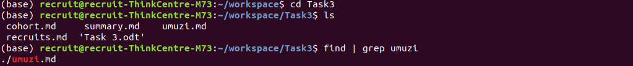
- Please see figure 2
figure 2
